**CopyTest  
10/11/2020 17:12:38**  
User Is Navigated To Site : http://172.19.9.53/ICRARevamp/#/login  
  
*****CopyTest is Started *****  
Username is entered  
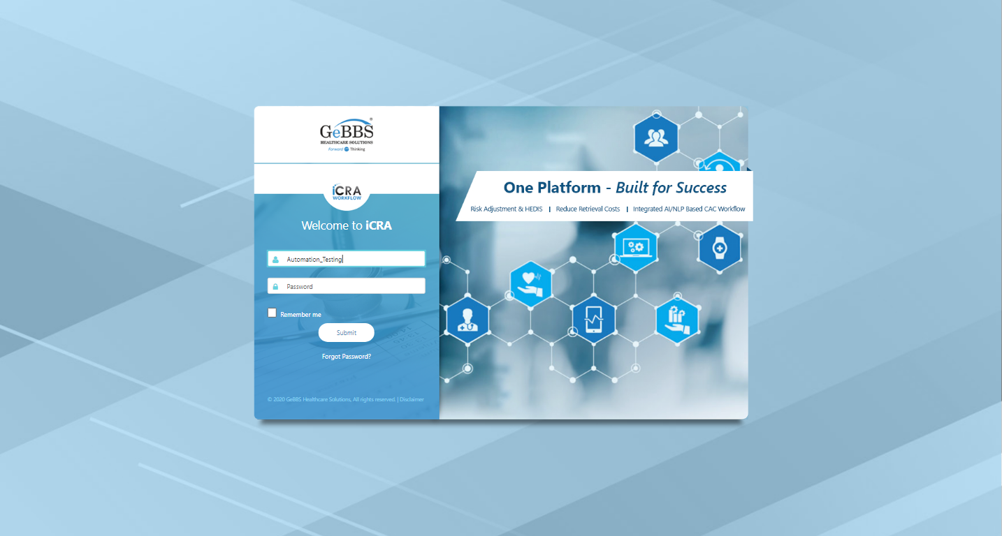  
Password is entered  
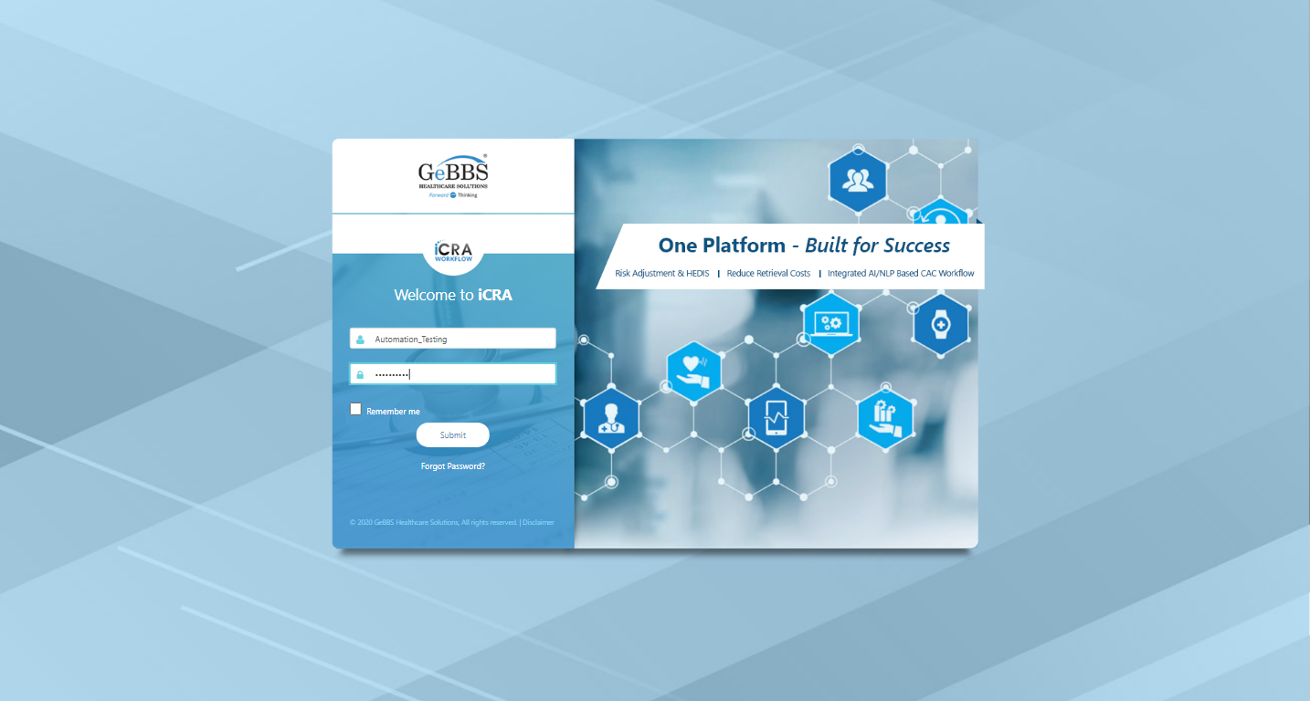  
Submit button is clicked  
Text of the element : Successfully logged in  
Successfully logged in  
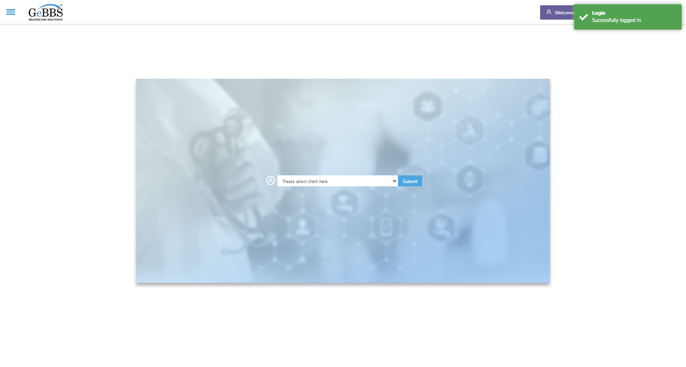  
Client dropdown button is clicked  
Client dropdown button is clicked  
Submit button is clicked  
Main Page loaded  
  
Scrolled successfully  
Chart Retrieval is clicked  
All submenus  
  
Submenu in 1 is :Field Tech  
Submenu in 2 is :FieldTech Area Assignment  
Submenu in 3 is :Intake  
Submenu in 4 is :RecordQA  
Submenu in 5 is :RecordQA Approval  
Scrolled successfully  
RecordQA is clicked  
RecordQA selected  
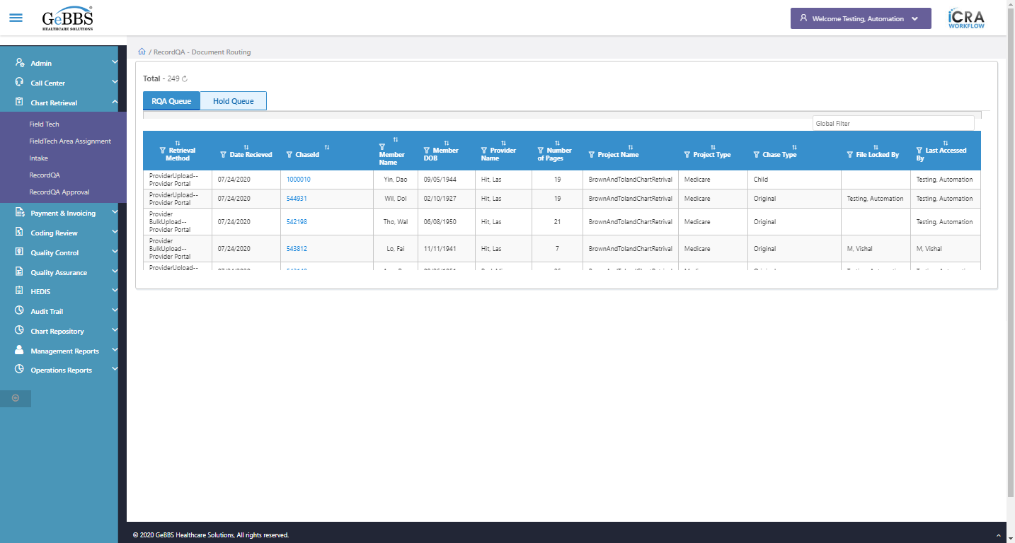  
 Retrieval Method is displayed  
  
text is correct  
  
1 th filter is displayed  
  
1 th sorting is displayed  
  
Sort is clicked  
1 th Asc-sorting is displayed  
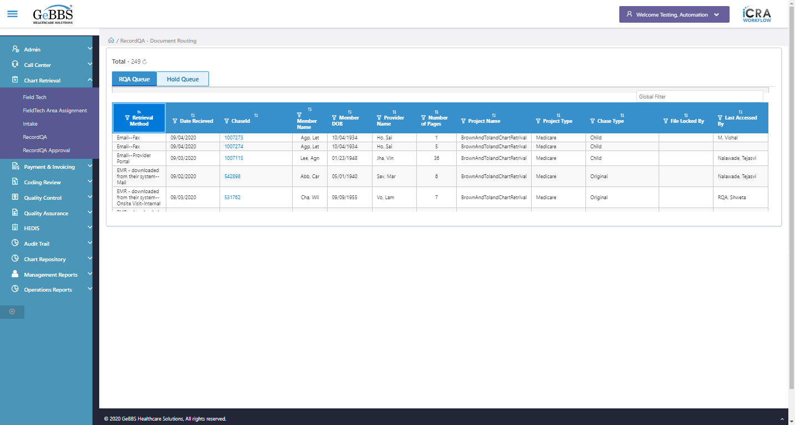  
Sort is clicked  
1 th dsc-sorting is displayed  
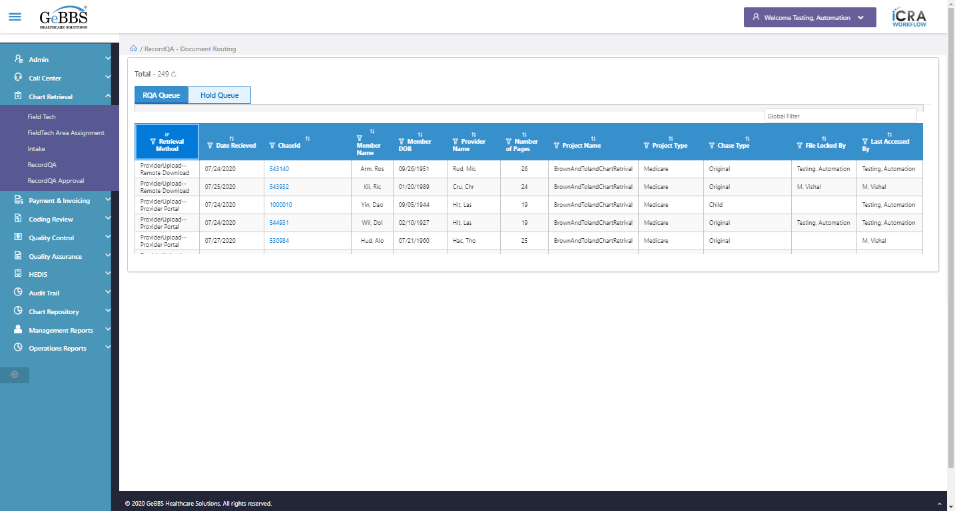  
 Date Recieved is displayed  
  
text is correct  
  
2 th filter is displayed  
  
2 th sorting is displayed  
  
Sort is clicked  
2 th Asc-sorting is displayed  
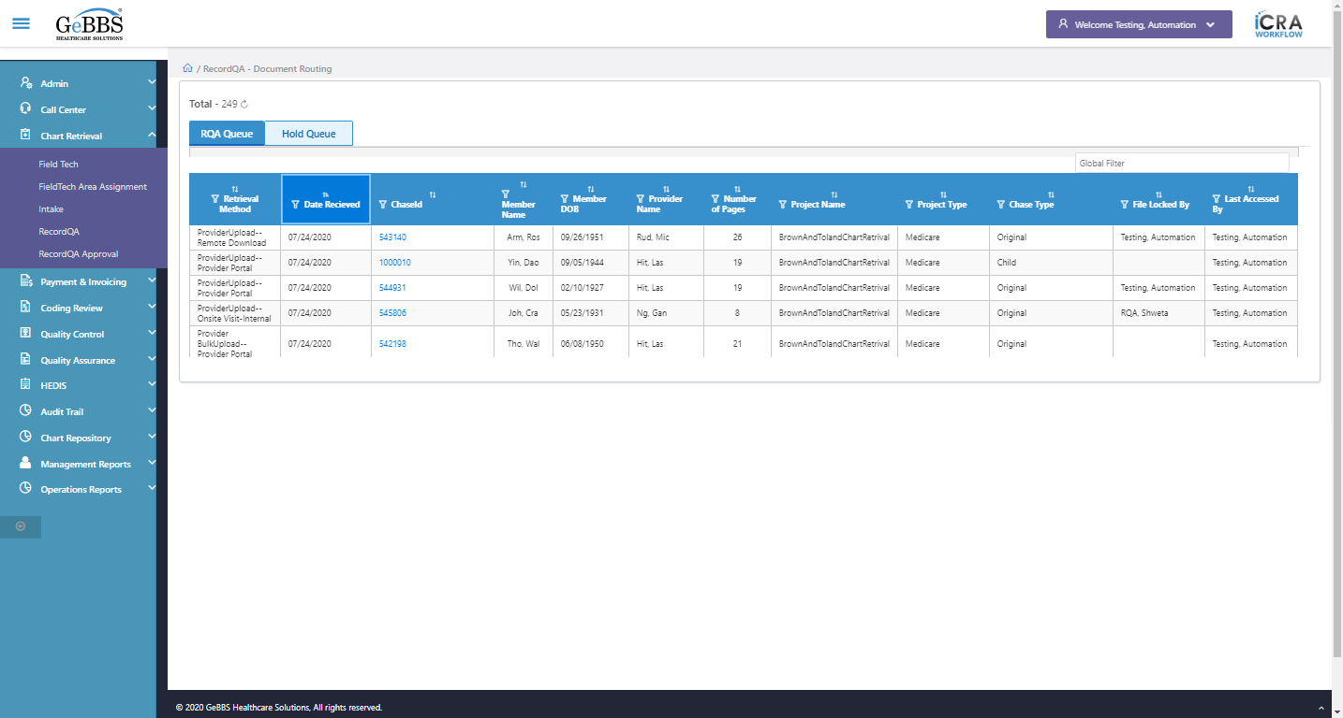  
Sort is clicked  
2 th dsc-sorting is displayed  
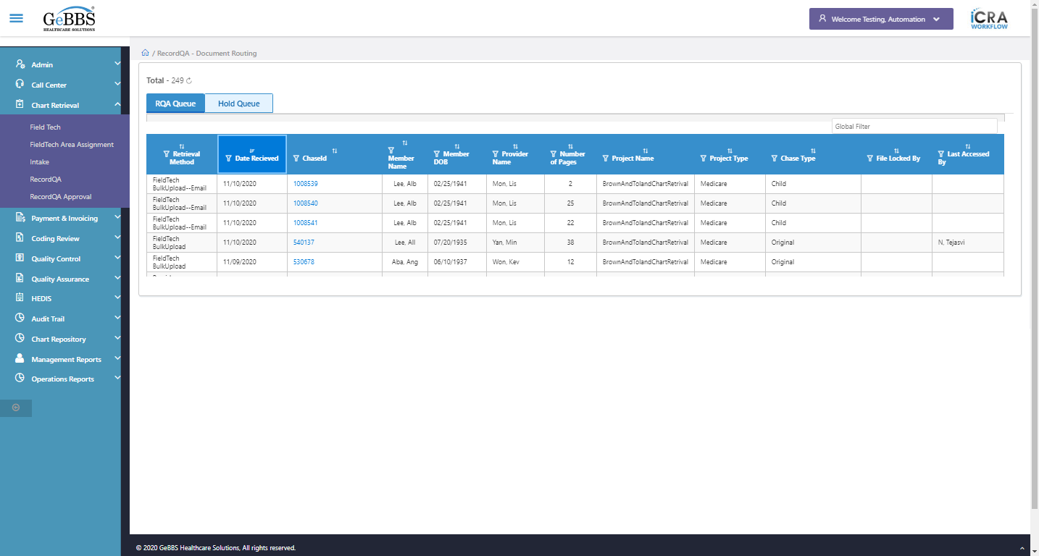  
 ChaseId is displayed  
  
text is correct  
  
3 th filter is displayed  
  
3 th sorting is displayed  
  
Sort is clicked  
3 th Asc-sorting is displayed  
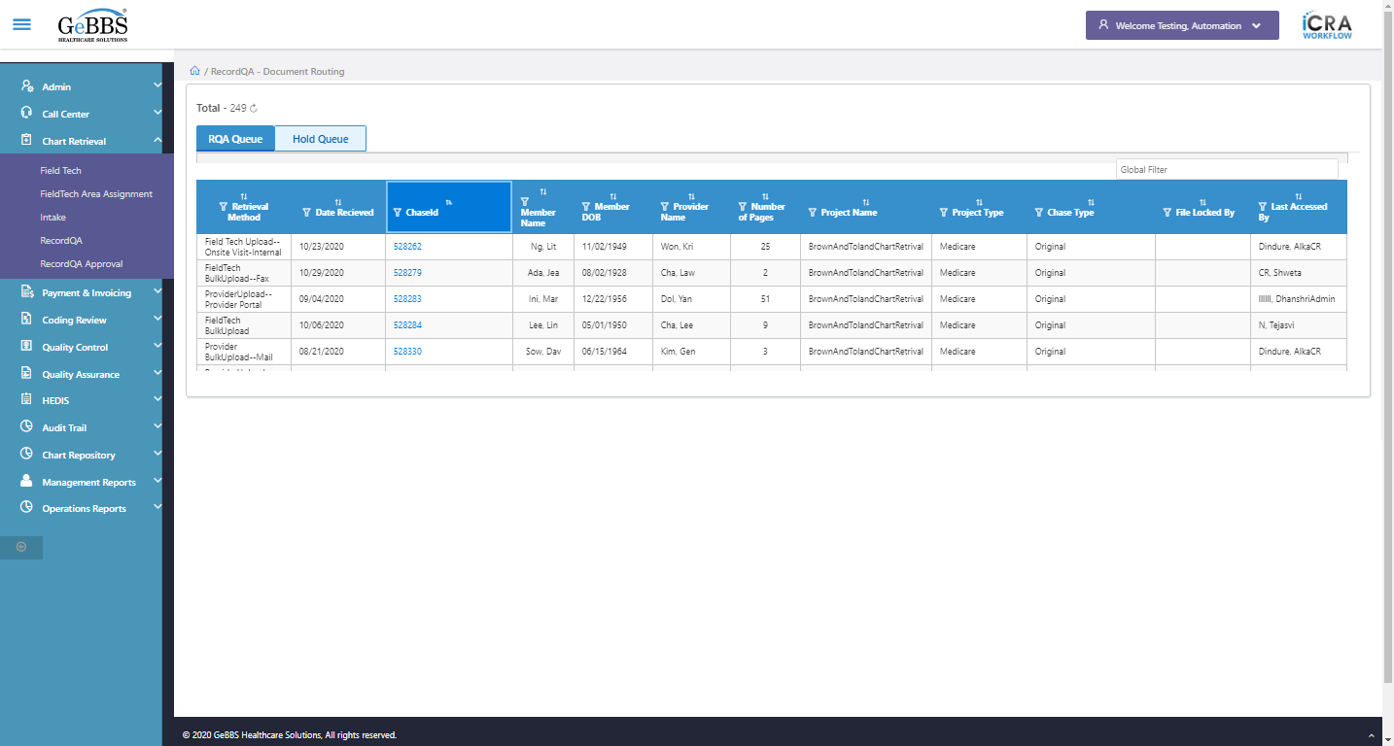  
Sort is clicked  
3 th dsc-sorting is displayed  
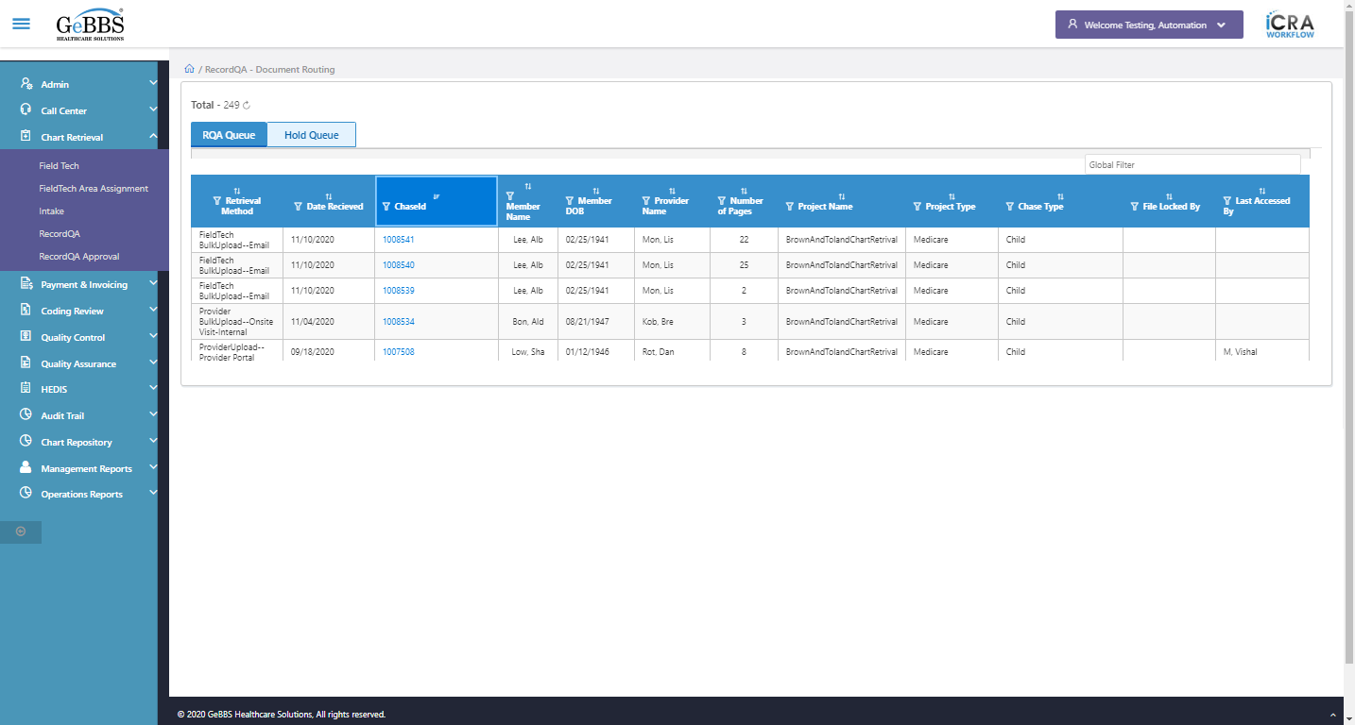  
 Member Name is displayed  
  
text is correct  
  
4 th filter is displayed  
  
4 th sorting is displayed  
  
Sort is clicked  
4 th Asc-sorting is displayed  
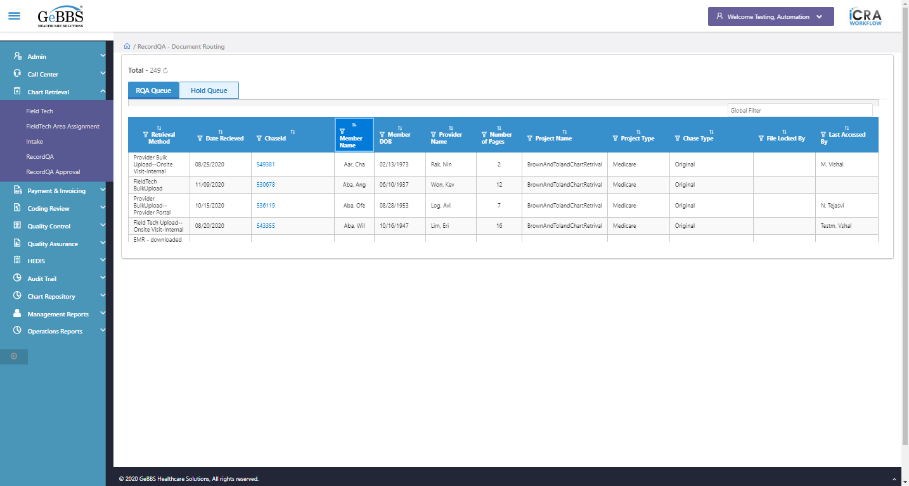  
Sort is clicked  
4 th dsc-sorting is displayed  
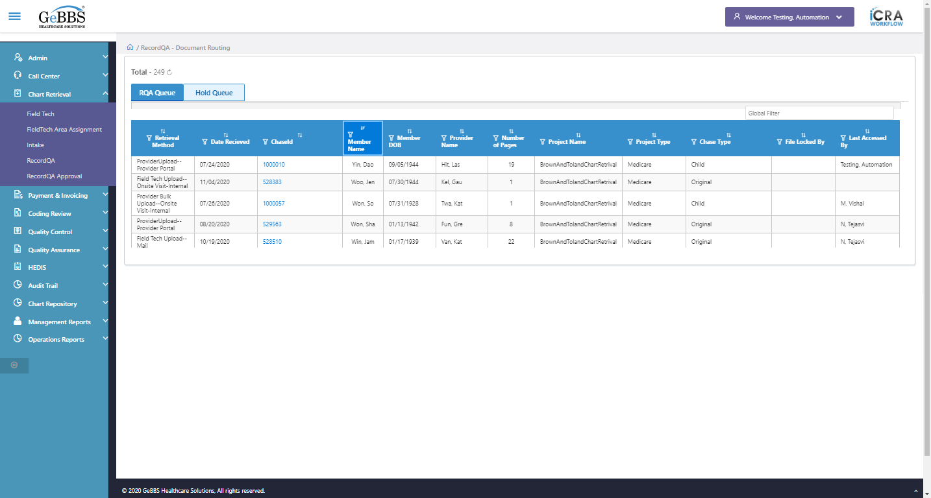  
 Member DOB is displayed  
  
text is correct  
  
5 th filter is displayed  
  
5 th sorting is displayed  
  
Sort is clicked  
5 th Asc-sorting is displayed  
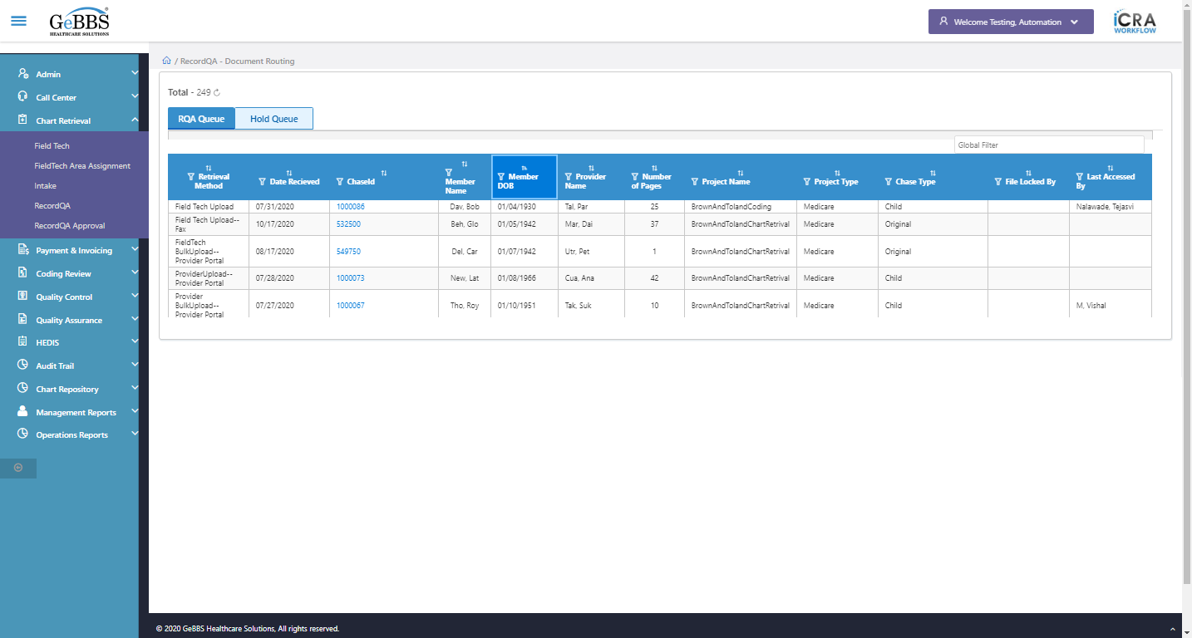  
Sort is clicked  
5 th dsc-sorting is displayed  
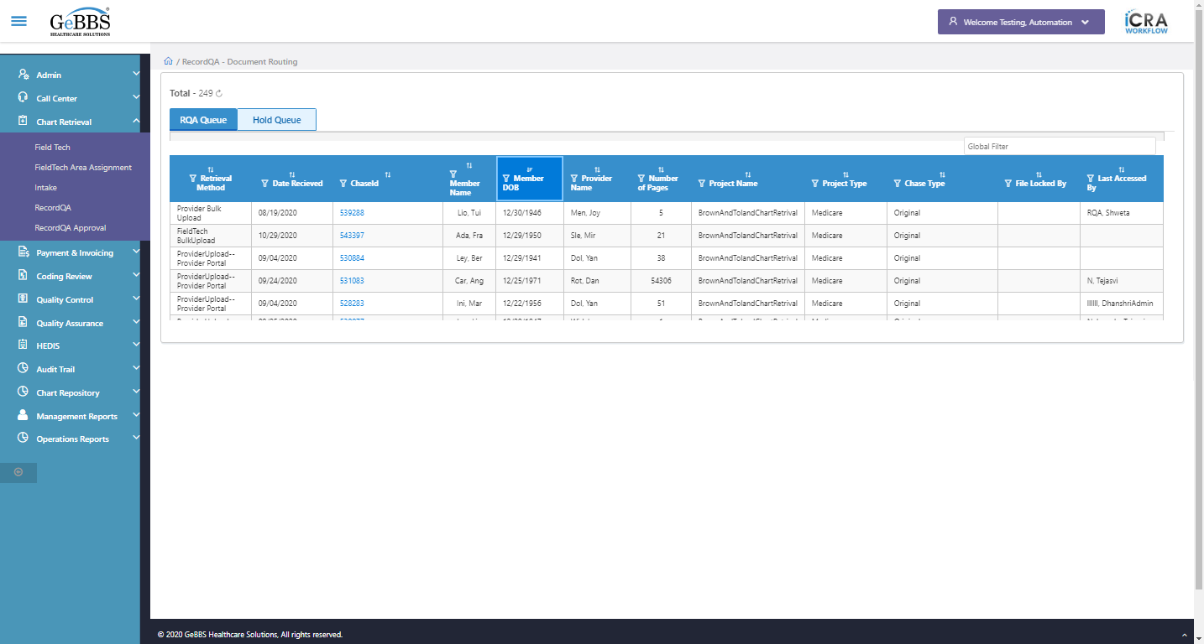  
 Provider Name is displayed  
  
text is correct  
  
6 th filter is displayed  
  
6 th sorting is displayed  
  
Sort is clicked  
6 th Asc-sorting is displayed  
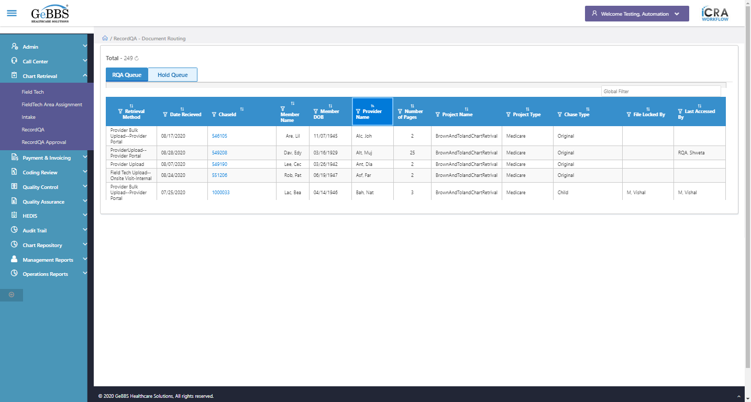  
Sort is clicked  
6 th dsc-sorting is displayed  
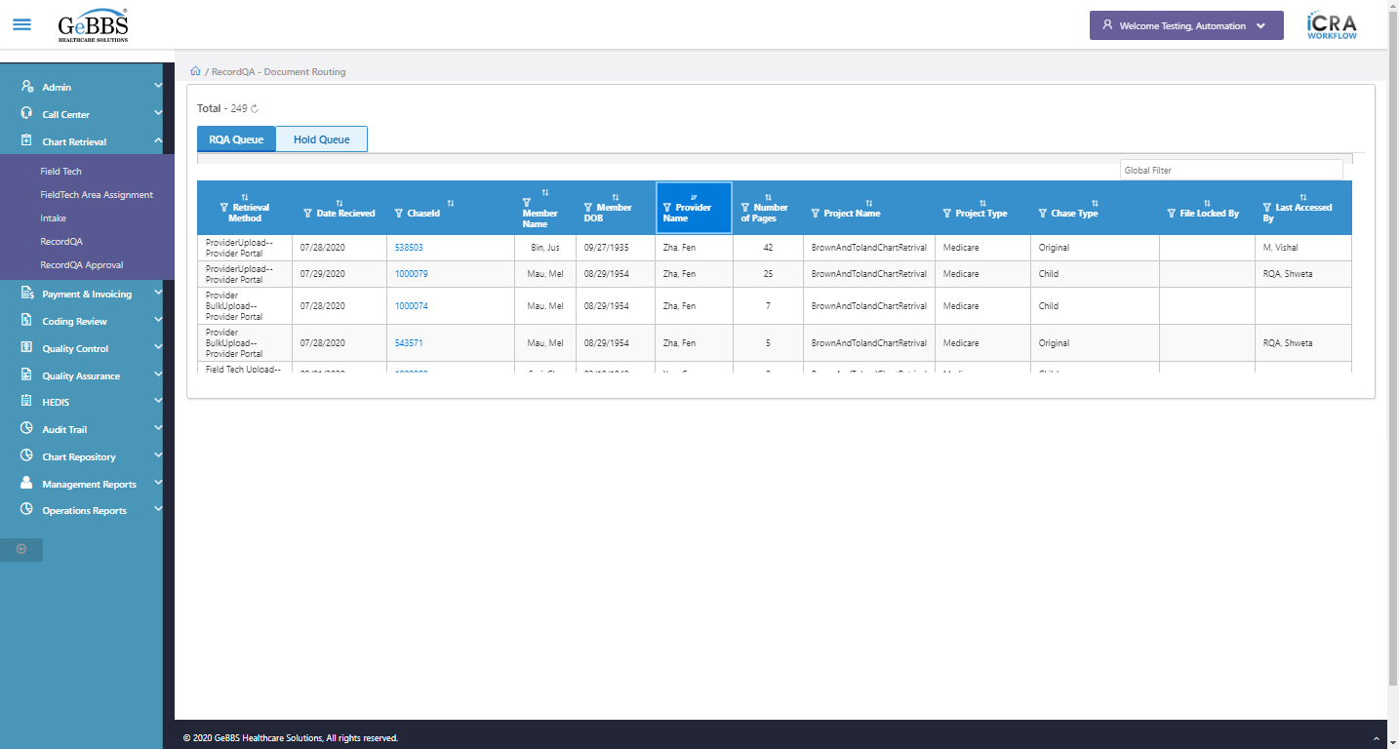  
 Number of Pages is displayed  
  
text is correct  
  
7 th filter is displayed  
  
7 th sorting is displayed  
  
Sort is clicked  
7 th Asc-sorting is displayed  
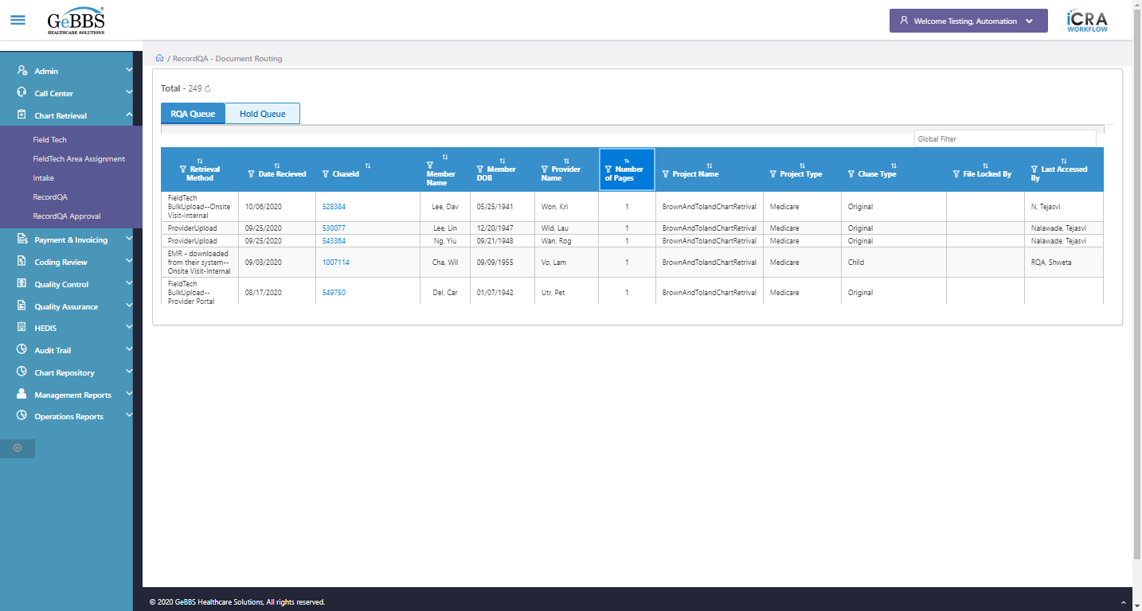  
Sort is clicked  
7 th dsc-sorting is displayed  
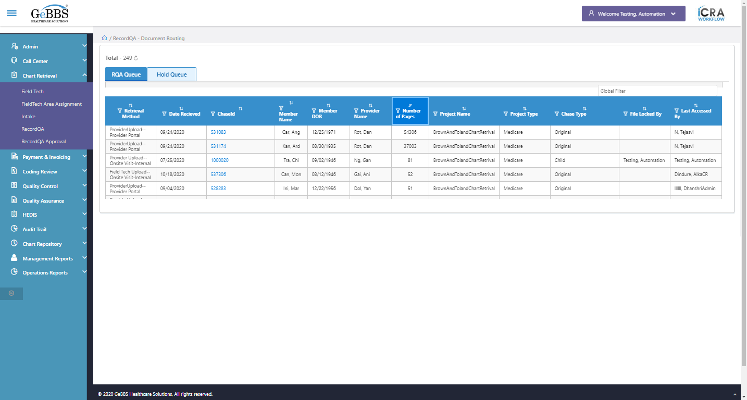  
 Project Name is displayed  
  
text is correct  
  
8 th filter is displayed  
  
8 th sorting is displayed  
  
Sort is clicked  
8 th Asc-sorting is displayed  
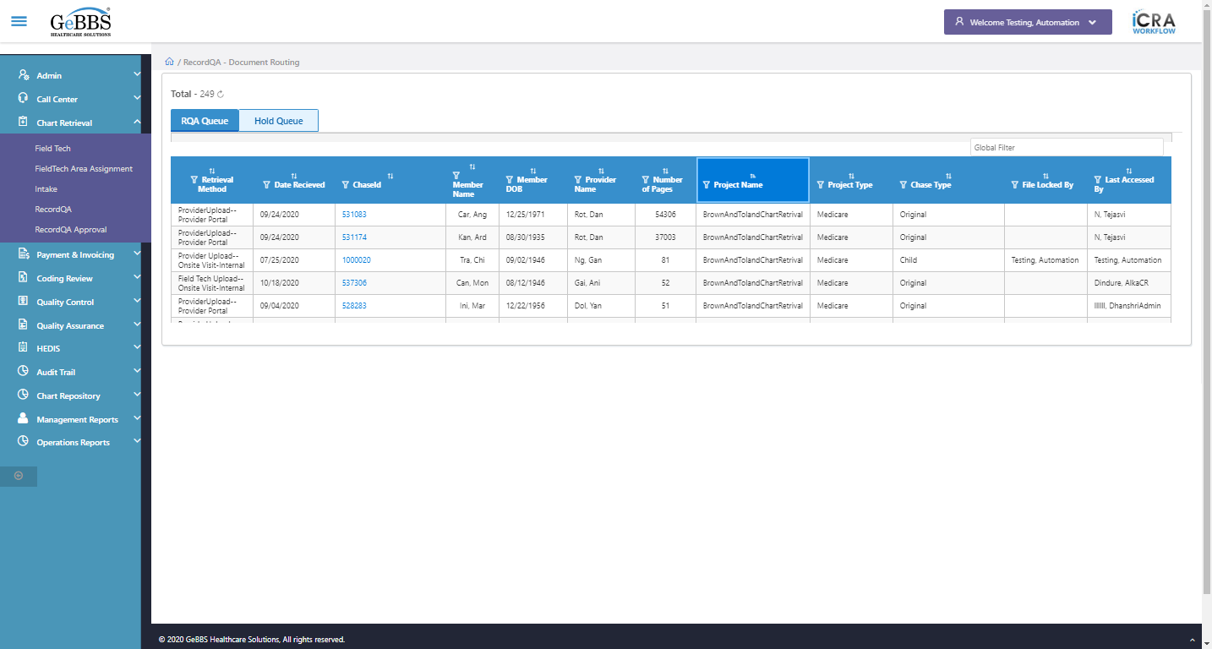  
Sort is clicked  
8 th dsc-sorting is displayed  
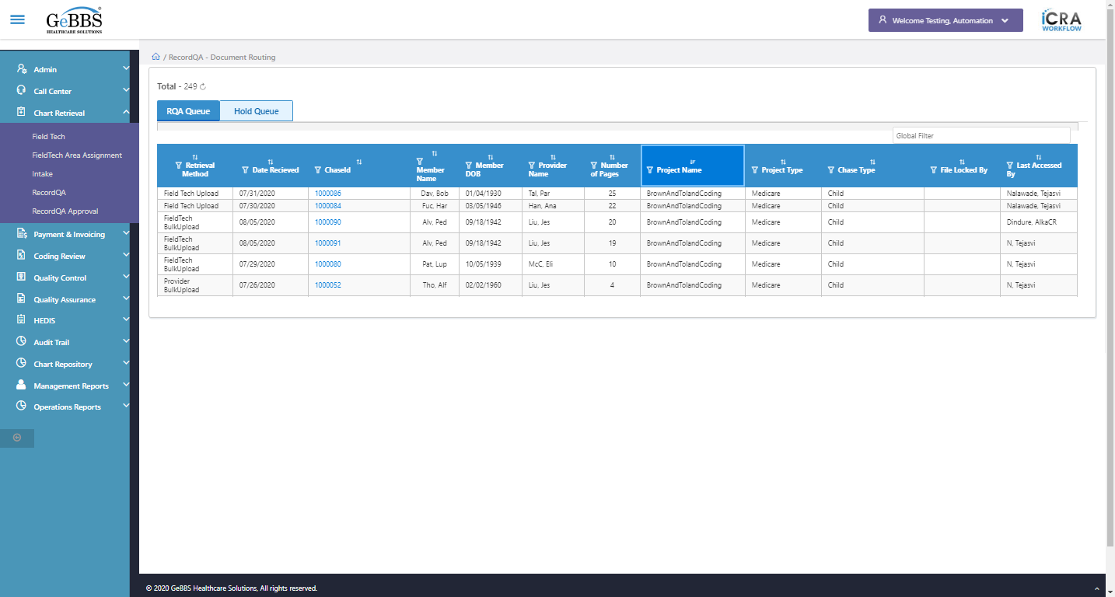  
 Project Type is displayed  
  
text is correct  
  
9 th filter is displayed  
  
9 th sorting is displayed  
  
Sort is clicked  
9 th Asc-sorting is displayed  
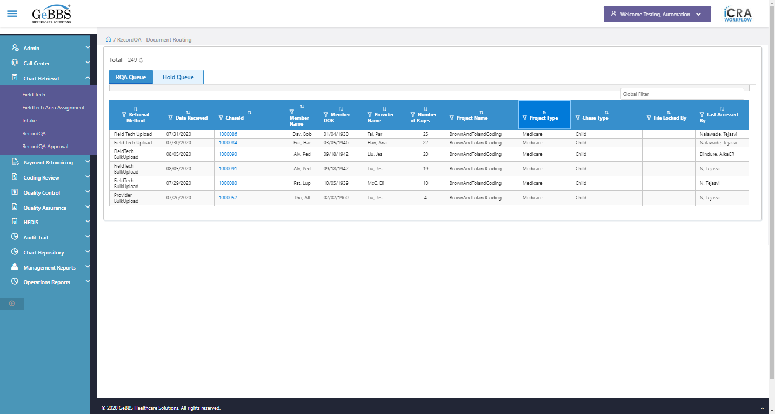  
Sort is clicked  
9 th dsc-sorting is displayed  
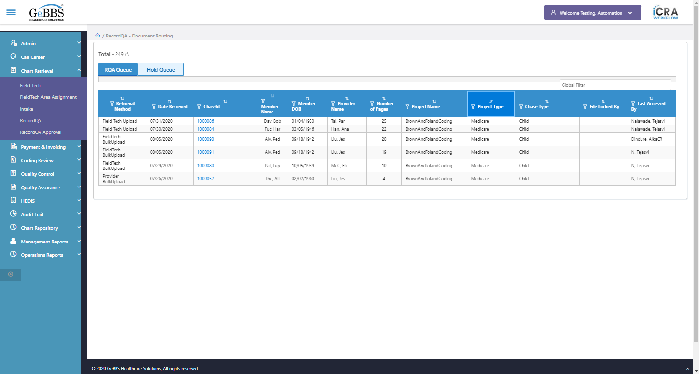  
 Chase Type is displayed  
  
text is correct  
  
10 th filter is displayed  
  
10 th sorting is displayed  
  
Sort is clicked  
10 th Asc-sorting is displayed  
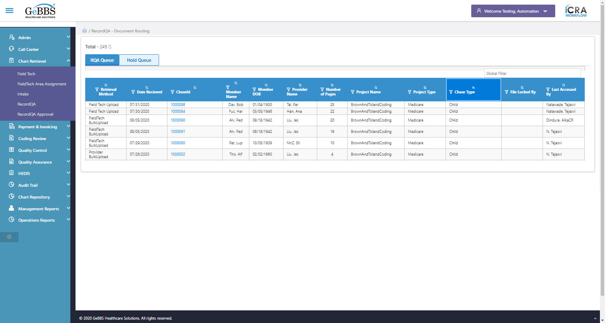  
Sort is clicked  
10 th dsc-sorting is displayed  
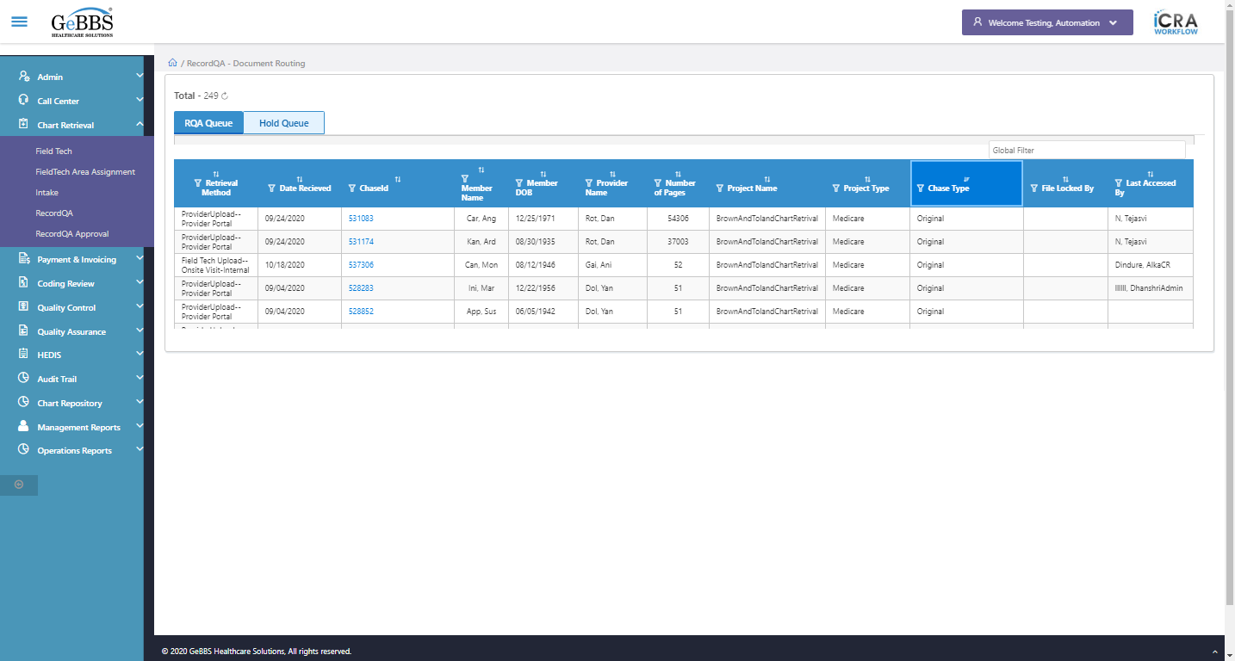  
 File Locked By is displayed  
  
text is correct  
  
11 th filter is displayed  
  
11 th sorting is displayed  
  
Sort is clicked  
11 th Asc-sorting is displayed  
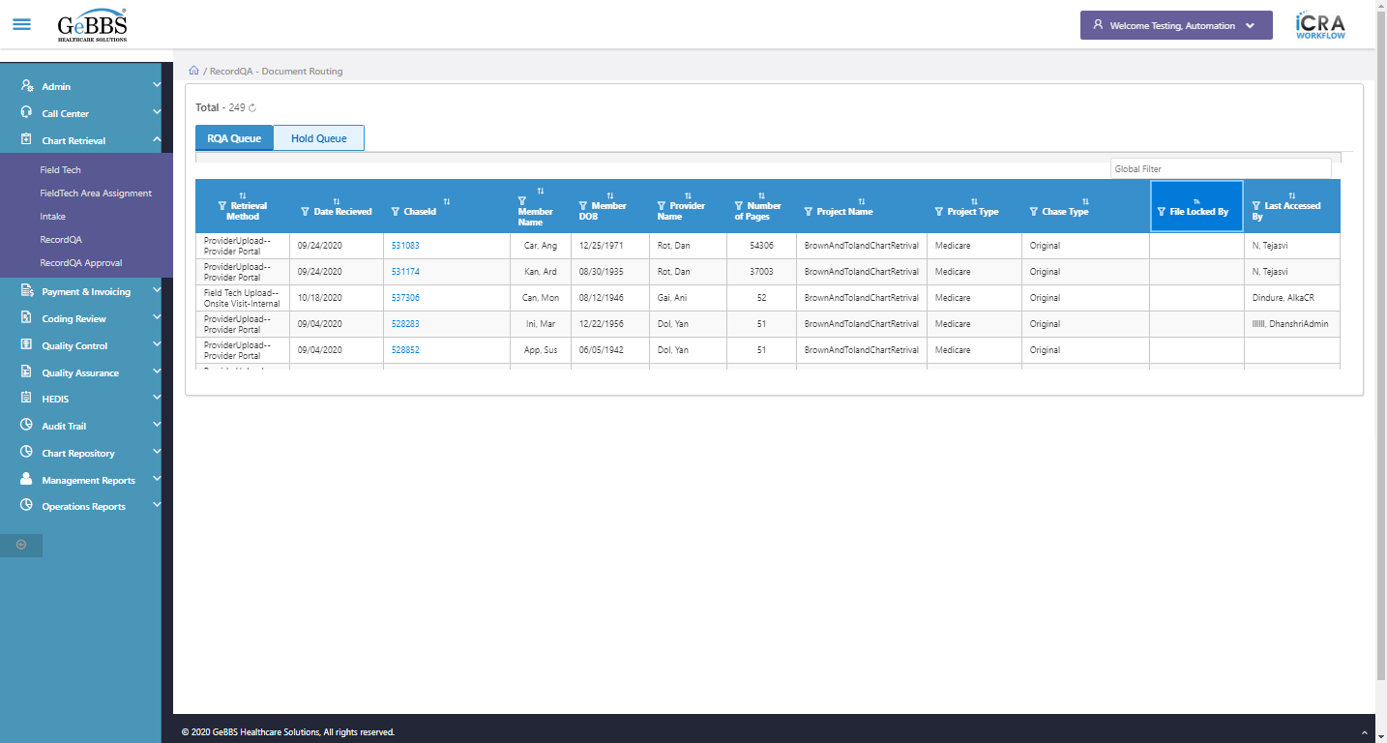  
Sort is clicked  
11 th dsc-sorting is displayed  
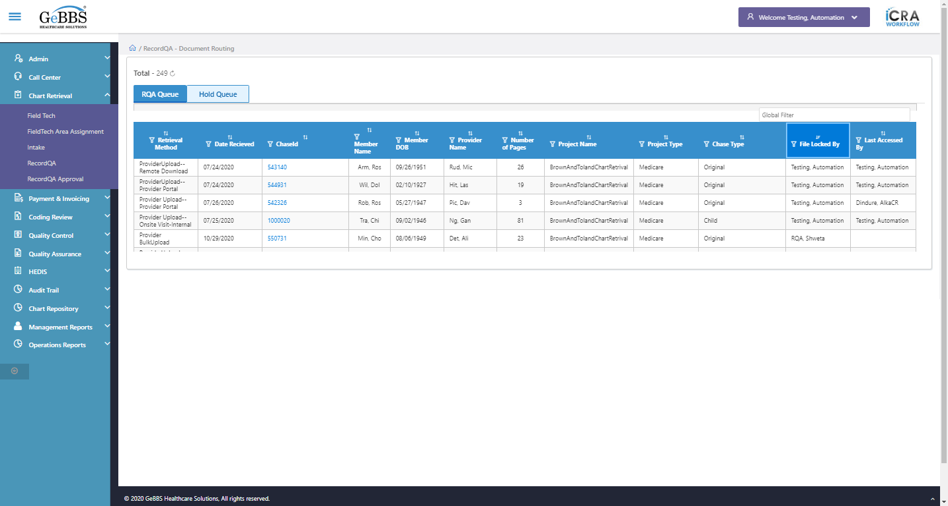  
 Last Accessed By is displayed  
  
text is correct  
  
12 th filter is displayed  
  
12 th sorting is displayed  
  
Sort is clicked  
12 th Asc-sorting is displayed  
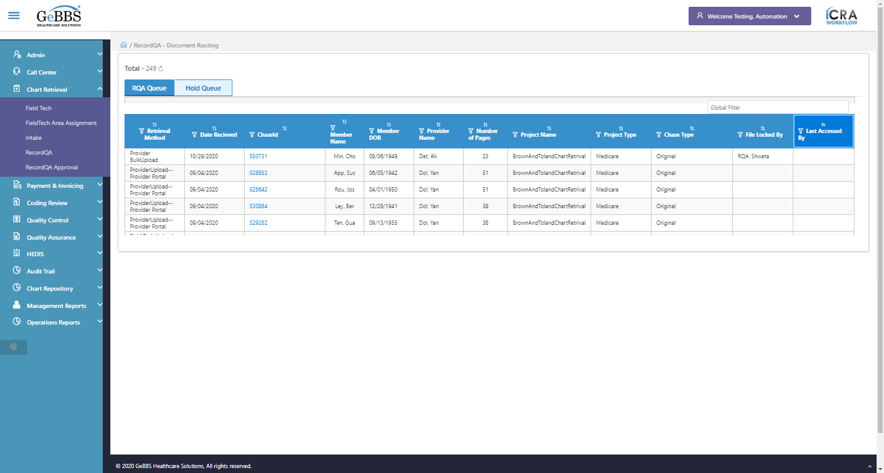  
Sort is clicked  
12 th dsc-sorting is displayed  
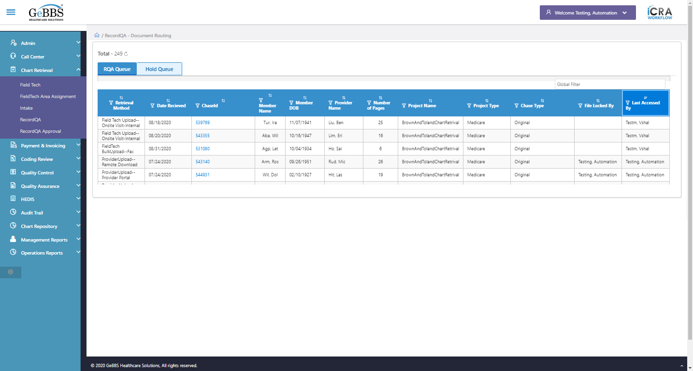  
Scrolled successfully  
Text of the element : 1000010  
GolbalFilter is entered  
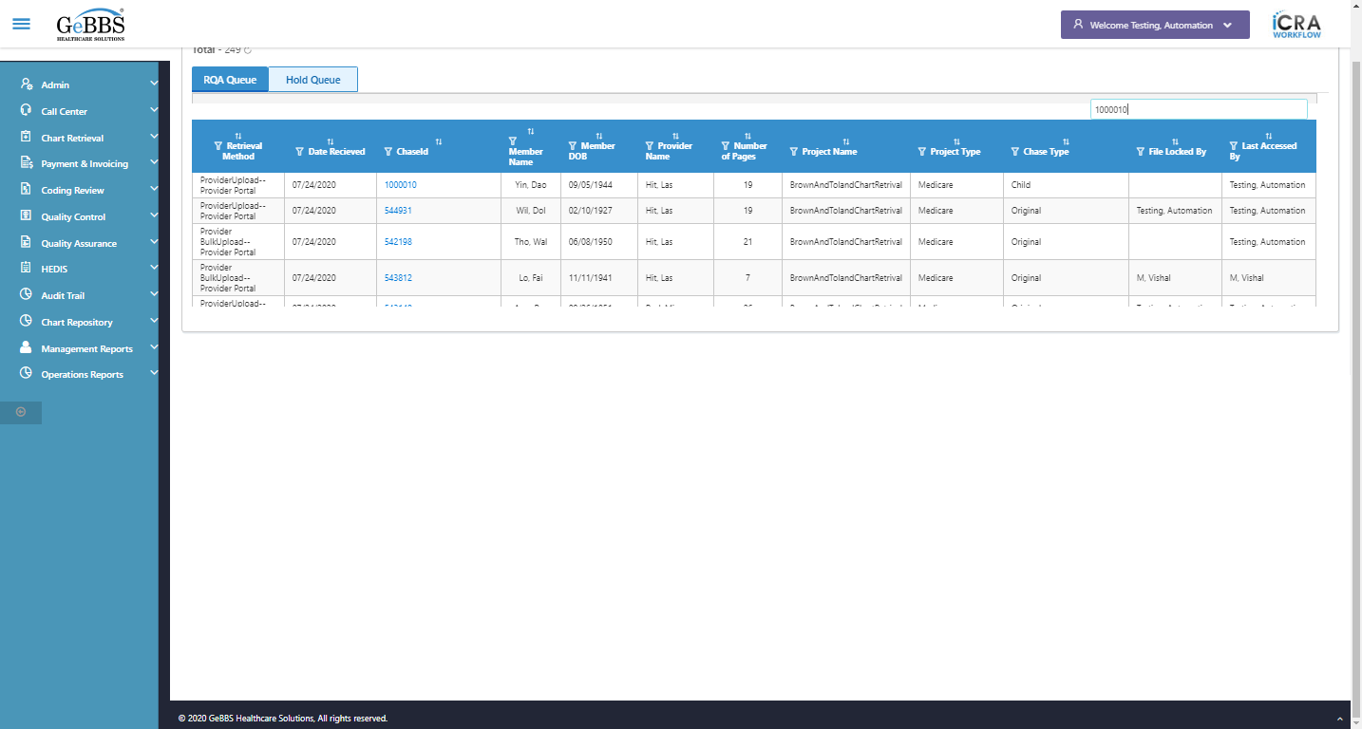  
Text of the element : 19  
Scrolled successfully  
Scrolled successfully  
Scrolled successfully  
Text of the element : 542198  
GolbalFilter is entered  
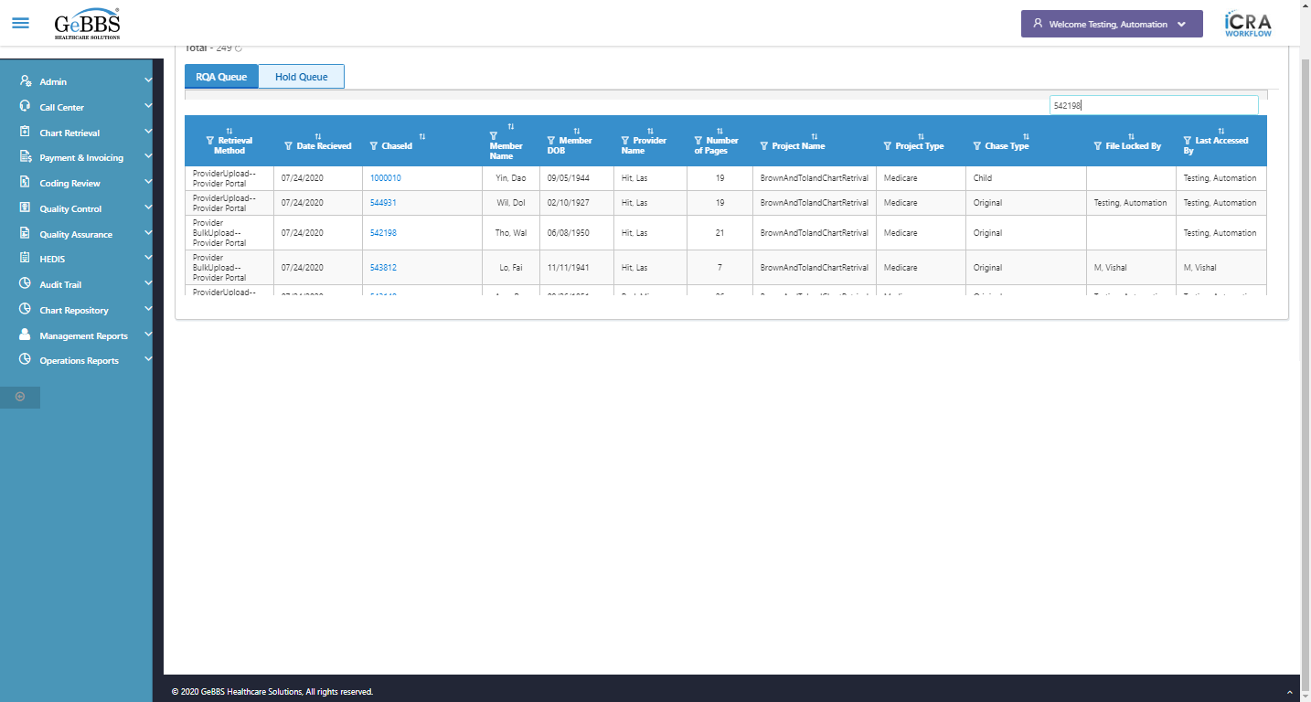  
Text of the element : 21  
The old chase for move or copy:1000010  
Total pages of old chase in grid before move or copy:19  
The new chase for move or copy:542198  
Total pages of new chase in grid before move or copy:21  
Text of the element : Tho, Wal  
Text of the element : Hit, Las  
GolbalFilter is entered  
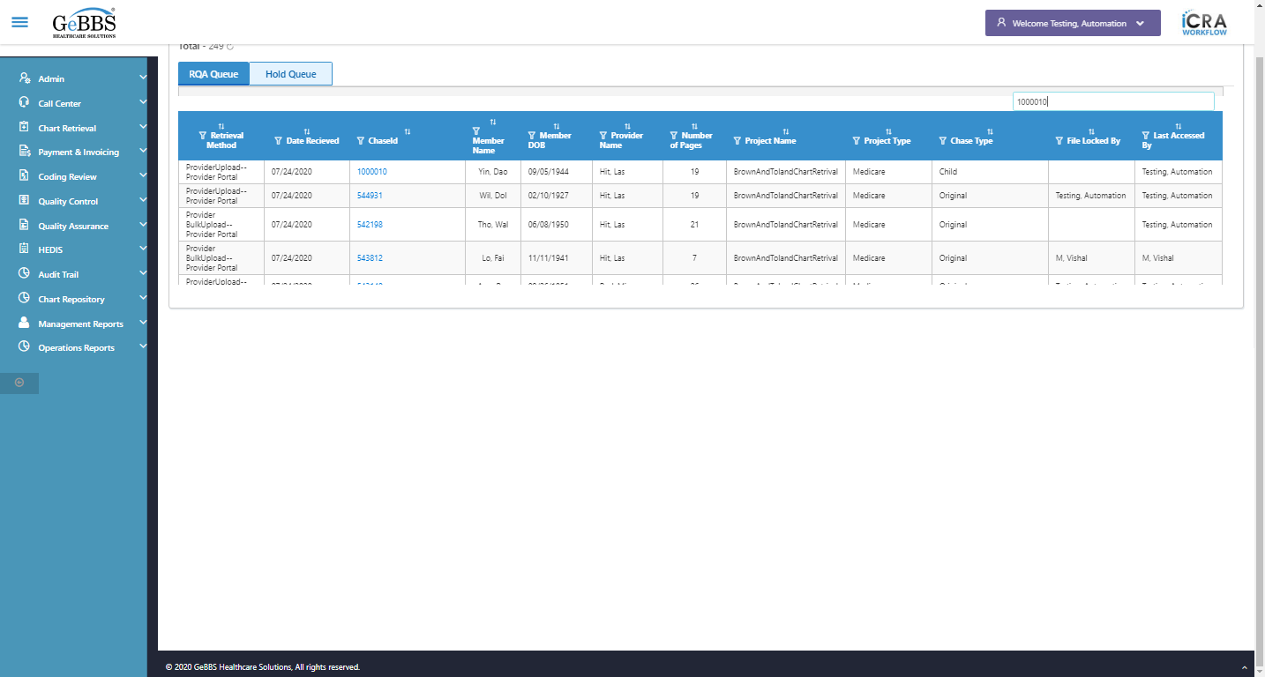  
chaseid is clicked  
Frame found and switched to   
PDF File is present   
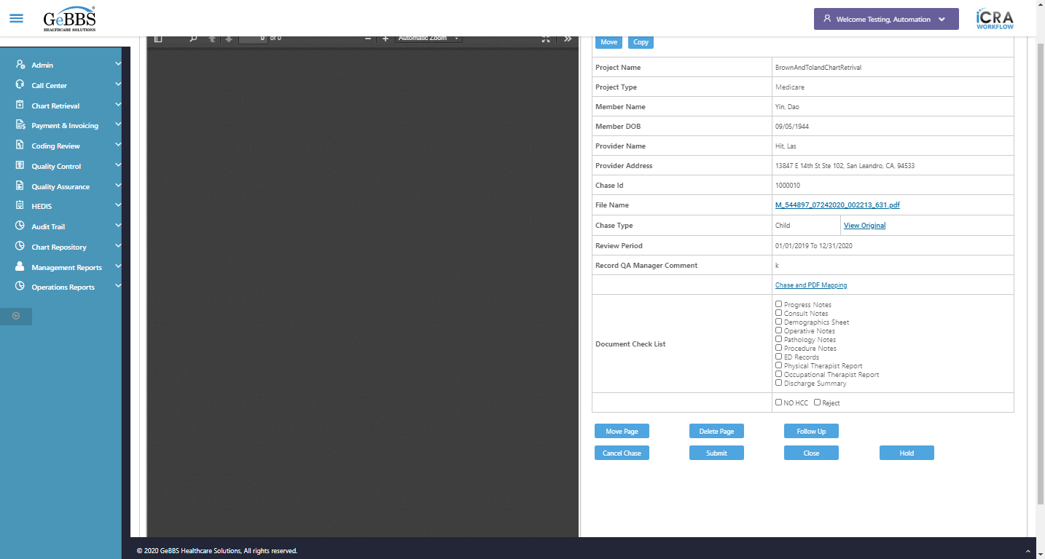  
GetMaxPageNo_Chase() failed - no such element: Unable to locate element: {"method":"xpath","selector":"//iframe[@title='ng2-pdfjs-viewer']"}
(Session info: chrome=86.0.4240.183)
For documentation on this error, please visit: https://www.seleniumhq.org/exceptions/no_such_element.html
Build info: version: '3.141.59', revision: 'e82be7d358', time: '2018-11-14T08:17:03'
System info: host: 'GEBBSET17063', ip: '172.30.54.166', os.name: 'Windows 10', os.arch: 'amd64', os.version: '10.0', java.version: '13.0.1'
Driver info: org.openqa.selenium.chrome.ChromeDriver
Capabilities {acceptInsecureCerts: false, browserName: chrome, browserVersion: 86.0.4240.183, chrome: {chromedriverVersion: 85.0.4183.87 (cd6713ebf92fa..., userDataDir: C:\Users\nishinde\AppData\L...}, goog:chromeOptions: {debuggerAddress: localhost:54633}, javascriptEnabled: true, networkConnectionEnabled: false, pageLoadStrategy: normal, platform: WINDOWS, platformName: WINDOWS, proxy: Proxy(), setWindowRect: true, strictFileInteractability: false, timeouts: {implicit: 0, pageLoad: 300000, script: 30000}, unhandledPromptBehavior: dismiss and notify, webauthn:virtualAuthenticators: true}
Session ID: 73c58b276ceda4acef8fe3a2110ae1b5
*** Element info: {Using=xpath, value=//iframe[@title='ng2-pdfjs-viewer']} **10/11/2020 17:16:32**